HONOR FLIGHT OF CENTRAL OREGON (HFCO)

FACT SHEET

Honor Flight of Central Oregon (HFCO) is one of 144 regional “hubs” in 44 states participating in the national Honor Flight Network honoring Korean War veterans by taking them to Washington, DC to visit THEIR National Korean War Memorial. HFCO is a 501 (c) (3) non-proﬁt, tax exempt organization (IRS EIN 81-1201731). The HFCO service area includes all of Deschutes, Jefferson and Crook counties. The Korean War is also known as the "Forgotten War."

About 200,000 veterans from all wars and from across our nation have participated in the Honor Flight Network program launched in May of 2005. Korean War Veterans travel free of charge in appreciation for their service and sacrifice over 6 decades ago. “Guardians” assisting veterans pay HFCO for their lodging, meals, and bus/airline expenses - about $1,250 and subject to change. Our trips are reserved for Korean War Veterans only. They will not be forgotten.

Sixty percent (60%) of the 5.7 million Korean War Veterans who served during the Korean War have passed away. The average age of the surviving 2.5 million Korean War Veterans is mid-80s. Approximately 1,400 Korean War Veterans live in Central Oregon. Time is of the essence to honor as many of them as we can.

To travel on an Honor Flight of Central Oregon trip, Korean War Veterans must:
Have served anywhere in the Armed Forces between June 27, 1950 — January 31, 1955. Live within Deschutes, Jefferson and Crook Counties, Not have visited the National Korean War Memorial in the past, and be physically able to travel and have a Guardian.

We take Veterans using wheelchairs, canes, walkers and oxygen. We encourage veterans to have an able bodied family member, relative, or friend serve as their guardian. Guardians must be able to push a veteran in a wheelchair. Terminally ill veterans of any war are given top priority under certain conditions. We have medical staff on our trips.

Our Korean War Veterans and their Guardians will visit the National Korean War Memorial (photos next page), U.S. Capitol, WWII, Lincoln, Vietnam, Navy, Air Force, Marine (Iwo Jima Memorial) memorials, Women in Military Service for America Museum and Tomb of the Unknowns at Arlington National Cemetery. Our trips are four days in duration: a day traveling from Portland to Washington, 2 full days in Washington, and part of a day returning to a Heroes welcome at Portland airport (PDX).

For more information on the National Honor Flight program please visit www.honorflight.org/, www.bendheroes.org. The Honor Flight of Central Oregon web site is: www.honorflightofcentraloregon.org.

This year's Honor Flight trip is scheduled for May 6 - 9, 2020 and announced on our website and social media. Contacts:

Georgea Edwards, Honor Flight Central Oregon Fundraiser, Cell: 503-913-8483.
Email: HonorFlightCO@gmail.com

Mailing address: Honor Flight of Central Oregon
P.O. Box 7963, Bend, Oregon 97708

Honor Flight of Central Oregon is recognized by the IRS as a 501 (c) (3) Public Charity and State of Oregon as a Public Interest Not for Profit Corporation, EIN 81-12011731.
Contributions to the Honor Flight of Central Oregon are tax deductible.

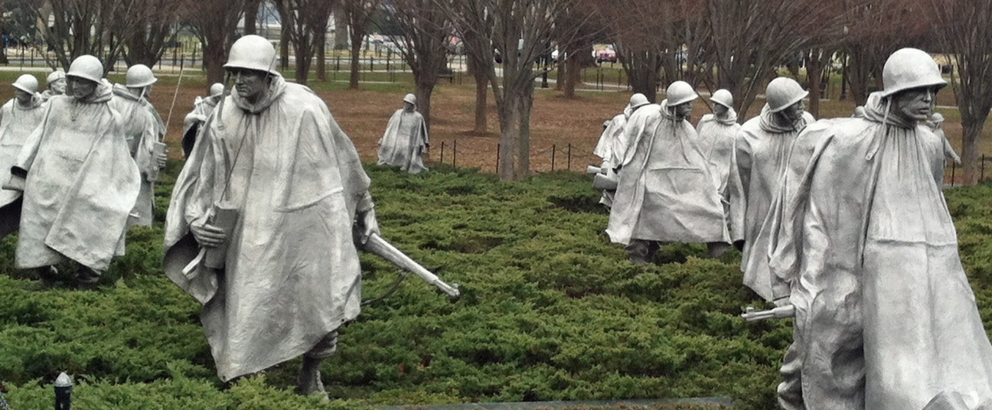

NATIONAL KOREAN WAR MEMORIAL
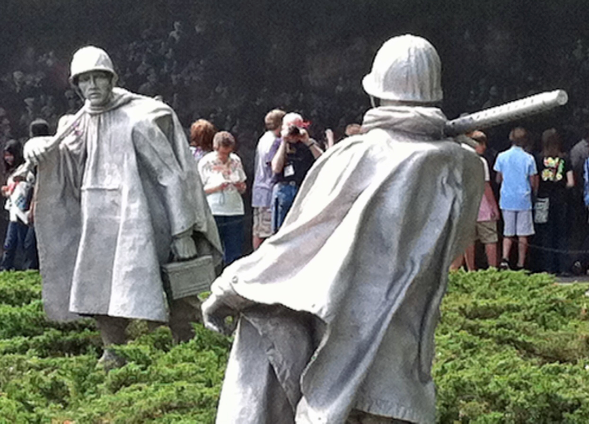
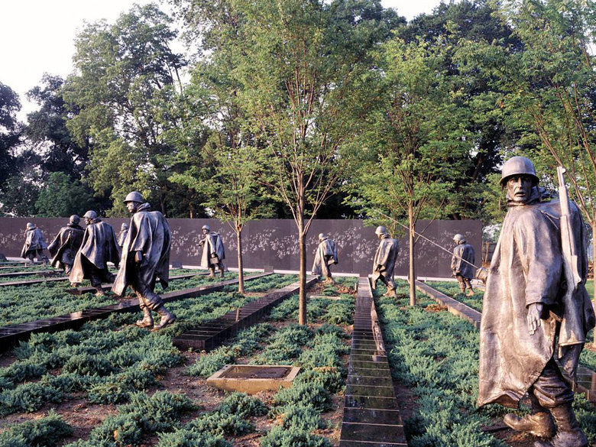
WASHINGTON, DC

